# Exercise - Deploy an Azure Functions app to Azure

Your project came with a release pipeline that builds the projects in the solution and deploys the web app to Azure App Service. Now it's time to extend that pipeline to also deploy the new Azure Functions project.

In this part, you'll:

* Review the Build stage.
* Add a task to deploy your function app.
* Add a task configure the published App Service to use the published function.
* Save the pipeline to trigger a CI/CD workflow.

## Review the Build stage

Here you review the existing CI/CD pipeline defined in azure-pipelines.yml.

1. From Azure DevOps, navigate to **Pipelines**.
2. Select the pipeline.
3. Select **Edit**. This brings up the azure-pipelines.yml file that defines the existing CI/CD pipeline.

Because of the use of wildcards to the project paths, the highlighted tasks below will automatically restore, build, and publish the new Azure Functions project.

**yml**

stages:

- stage: 'Build'

displayName: 'Build the web application'

jobs:

- job: 'Build'

displayName: 'Build job'

pool:

vmImage: 'ubuntu-18.04'

demands:

- npm

variables:

wwwrootDir: 'Tailspin.SpaceGame.Web/wwwroot'

dotnetSdkVersion: '3.1.300'

steps:

- task: UseDotNet@2

displayName: 'Use .NET Core SDK $(dotnetSdkVersion)'

inputs:

version: '$(dotnetSdkVersion)'

- task: Npm@1

displayName: 'Run npm install'

inputs:

verbose: false

- script: './node_modules/.bin/node-sass $(wwwrootDir) --output $(wwwrootDir)'

displayName: 'Compile Sass assets'

- task: gulp@1

displayName: 'Run gulp tasks'

- script: 'echo "$(Build.DefinitionName), $(Build.BuildId), $(Build.BuildNumber)" > buildinfo.txt'

displayName: 'Write build info'

workingDirectory: $(wwwrootDir)

- task: DotNetCoreCLI@2

displayName: 'Restore project dependencies'

inputs:

command: 'restore'

projects: '**/*.csproj'

- task: DotNetCoreCLI@2

displayName: 'Build the project - $(buildConfiguration)'

inputs:

command: 'build'

arguments: '--no-restore --configuration $(buildConfiguration)'

projects: '**/*.csproj'

- task: DotNetCoreCLI@2

displayName: 'Publish the project - $(buildConfiguration)'

inputs:

command: 'publish'

projects: '**/*.csproj'

publishWebProjects: false

arguments: '--no-build --configuration $(buildConfiguration) --output $(Build.ArtifactStagingDirectory)/$(buildConfiguration)'

zipAfterPublish: true

- publish: '$(Build.ArtifactStagingDirectory)'

artifact: drop

**Andy:** This was our previous build stage. I didn't change it from the original project because the tasks were already configured to run against all projects based on the wildcard matching pattern.

**Mara:** Yes, this should work as-is. I don't think we need to make any changes here. After this build task runs, the zip file artifacts for both the web and leaderboard projects will be published for the Deploy stage to use.

## Add a task to deploy the Azure Function

**Andy:** I think we can also reuse the App Service deployment task as-is. Hopefully there's something similar we can use for deploying a function app.

**Mara:** I have good news. After a little research, it looks like there's a task that's conceptually similar to the App Service deployment task, but for Azure Functions deployments. Let's add it now.

## Azure Function App Task

The AzureFunctionApp@1 task is designed to deploy function apps. It is conceptually similar to the AzureWebApp@1 task and includes everything needed for this function app scenario:

* azureSubscription refers to the name of your Azure service connection pipeline variable.
* appType indicates whether the app is being deployed for Linux (functionAppLinux) or Windows (functionApp).
* appName specifies the name of the Azure Functions app instance in your Azure account.
* package specifies the path to the package to be deployed.
* runtimeStack indicates which image the function should be run on, which is required for Linux deployments.
* startUpCommand specifies the startup command to run after the function has been deployed, which is required for Linux deployments.

You can learn more about the flexibility of this task in the documentation for the [Azure Function App task](https://docs.microsoft.com/en-us/azure/devops/pipelines/tasks/deploy/azure-function-app).

Add the highlighted code below to the end of your pipeline.

**yml**

- stage: 'Deploy'

displayName: 'Deploy the web application'

dependsOn: Build

jobs:

- deployment: Deploy

pool:

vmImage: 'ubuntu-18.04'

environment: spike

variables:

- group: Release

strategy:

runOnce:

deploy:

steps:

- download: current

artifact: drop

- task: AzureWebApp@1

displayName: 'Azure App Service Deploy: website'

inputs:

azureSubscription: 'Resource Manager - Tailspin - Space Game'

appName: '$(WebAppName)'

appType: webAppLinux

package: '$(Pipeline.Workspace)/drop/$(buildConfiguration)/Tailspin.SpaceGame.Web.zip'

- task: AzureFunctionApp@1

displayName: 'Azure Function Deploy: leaderboard'

inputs:

azureSubscription: 'Resource Manager - Tailspin - Space Game'

appType: functionAppLinux

appName: '$(LeaderboardAppName)'

package: '$(Pipeline.Workspace)/drop/$(buildConfiguration)/Tailspin.SpaceGame.LeaderboardFunction.zip'

runtimeStack: DOCKER|microsoft/azure-functions-dotnet-core3.0:3.0

startUpCommand: 'func azure functionapp publish $(functionAppName) --no-bundler'

**Tip**

In a YAML file, whitespace is important. Ensure that the task you add here uses the same indentation as the previous task.

## Add a task to update the App Service's app settings

**Andy:** Now all we need to do is to configure the web app to use the published leaderboard API. We usually configure variables in the portal, but it would be better if we could do it here. It expects an AppSettings parameter named LeaderboardFunctionUrl.

**Mara:** I agree. Adding a task for that to our pipeline will help us avoid accidental oversights down the road if we change either service. We can put it right at the end.

Add the highlighted code below to the end of your pipeline. Be sure to match the the indentation of the task above it. If you would like to learn more about this task, you can review the docs for [Azure App Service Settings task](https://docs.microsoft.com/en-us/azure/devops/pipelines/tasks/deploy/azure-app-service-settings).

**yml**

- task: AzureFunctionApp@1

displayName: 'Azure Function Deploy: leaderboard'

inputs:

azureSubscription: 'Resource Manager - Tailspin - Space Game'

appType: functionAppLinux

appName: '$(LeaderboardAppName)'

package: '$(Pipeline.Workspace)/drop/$(buildConfiguration)/Tailspin.SpaceGame.LeaderboardFunction.zip'

runtimeStack: DOCKER|microsoft/azure-functions-dotnet-core3.0:3.0

startUpCommand: 'func azure functionapp publish $(functionAppName) --no-bundler'

- task: AzureAppServiceSettings@1

displayName: 'Update web app settings'

inputs:

azureSubscription: 'Resource Manager - Tailspin - Space Game'

appName: $(WebAppName)

resourceGroupName: $(ResourceGroupName)

appSettings: |

[

{

"name": "AppSettings:LeaderboardFunctionUrl",

"value": "http://$(LeaderboardAppName).azurewebsites.net/api/LeaderboardFunction",

"slotSetting": false

}

]

**Save the pipeline to trigger a build and release**

1. Select **Save** from the top right corner of the page. Confirm the **Save** to trigger a run.
2. In Azure Pipelines, go to the build. Trace the build as it runs.
3. After the build has succeeded, select the web site's deploy task and click the URL to view the deployed site.

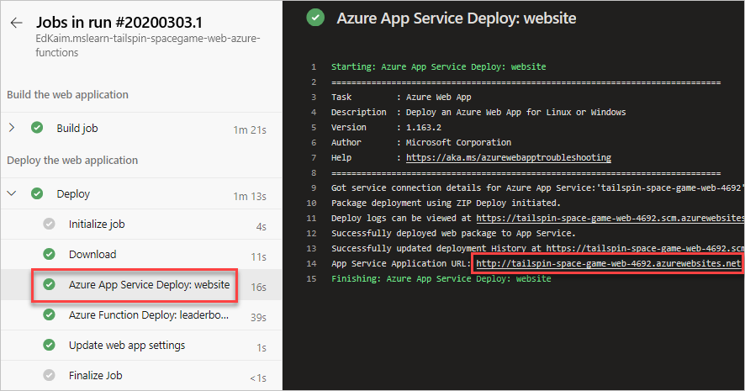

1. You see the site running on App Service. Scroll down to confirm that the leaderboard has real data in it. This is powered by the function app.

**Note**

If there is an error loading the leaderboard, double-check the steps followed in this module. If you see the exception message "An attempt was made to access a socket in a way forbidden by its access permissions", make sure that the app service's AppSettings:LeaderboardFunctionUrl setting is being set correctly.

1. You can also test out the function app directly. Just navigate to your URL using the format below. The response is JSON, which should just render as text in your browser.

Copy

http://<leaderboard function name>.azurewebsites.net/api/LeaderboardFunction?pageSize=10

such as

Copy

<http://tailspin-space-game-leaderboard-4692.azurewebsites.net/api/LeaderboardFunction?pageSize=10>

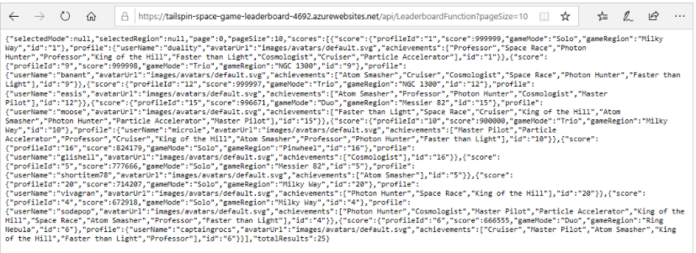

**Andy:** This turned out great! Everyone should be pretty impressed with the potential we've shown here.